Project 2: Extract, Transform, and Load
World Population
Members:
Jacob Page, Rahmi Rahmiev, Kazimierz Lubas, Badrija Khalifa, Samanthi Jayarathna, Amar Rai
Objective of the project:
The goal for this project was to find recent data for the world population – by country, as well as data regarding the area of countries to determine which are the most densely populated countries and regions in the world. After selecting an appropriate data source, the data was then cleaned as needed and loaded onto a database. In this case, into a relational database of our choice – SQL. After extracting and loading, we then used the data to answer our main question as well as others, all of which are outlined below.
Extract:
For this project we extracted 2 datasets from 2 different data platforms: Kaggle and Data.World on World Population with different sets of information. The data including the following information:
- Country
- Population
- Date
- Land Area
- Density
The data was primarily from 2022
Following sources for datasets used:
https://www.kaggle.com/datasets/khaiid/world-population
https://data.world/jst5th/country-population-land-area-density

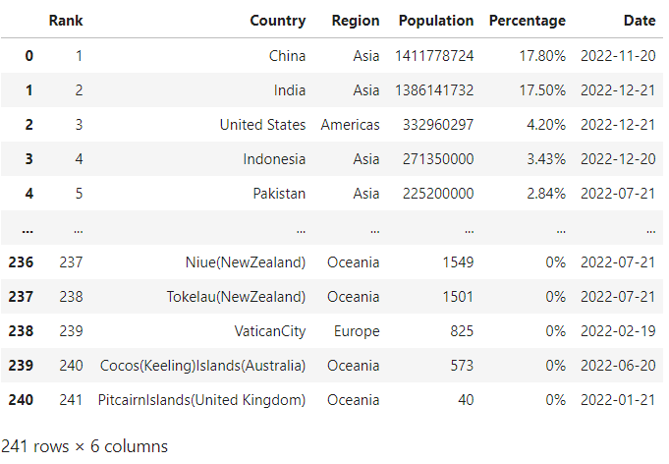
World Population dataset:
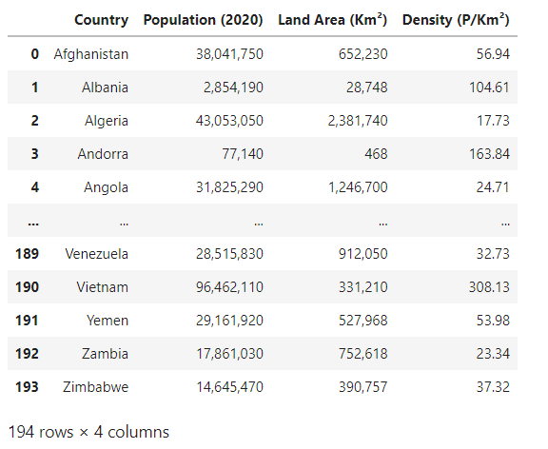
Country Population land area density dataset:
All of the data we extracted were in CSV file format.

Transform:
- In order to transform the public data and use it in our study we performed the following:
- Used Pandas functions in Jupyter Notebook to load all two CSV files.
- Loaded the files and transformed into data frames for better visualisation
- Dropped the “Rank” column and the “Population (2020)” columns as the final table had an up to date population column and there was missing information.
- Created empty tables on SQL with columns names and datatypes.
- Renamed some columns to mirror the columns created from CSV to be able to call it in SQL Server. We also removed commas from data to be able to fit the datatypes and transformed the date column so it took the SQL DATE format of YYYY-MM-DD to also be called in SQL with correct datatype. A few rows with NA were dropped.
- We changed the data types to see what suited the data the best.
- Created queries by grouping the data by country id and viewing the merged table.

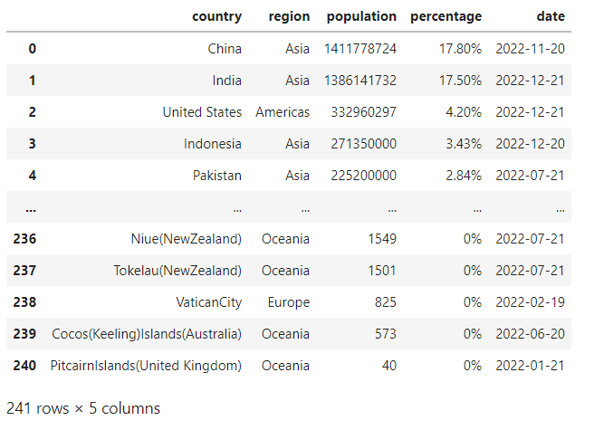
Cleaned World Population dataset:

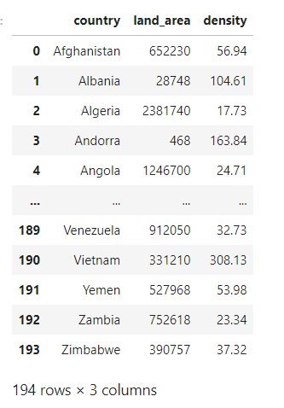
Cleaned Country Population dataset:

Load:
After pulling the CSV files and loading them as dataframes onto Python, we created a database connection to Postgres SQL using PG admin to store our data sets. Once we uploaded the tables, we checked that the tables were correctly generated to Postgres SQL and merged the table on SQL which we loaded and read onto python. We ran the queries and a final table with all correct and relevant information was generated to now be manipulated in Python to help us answer our questions.

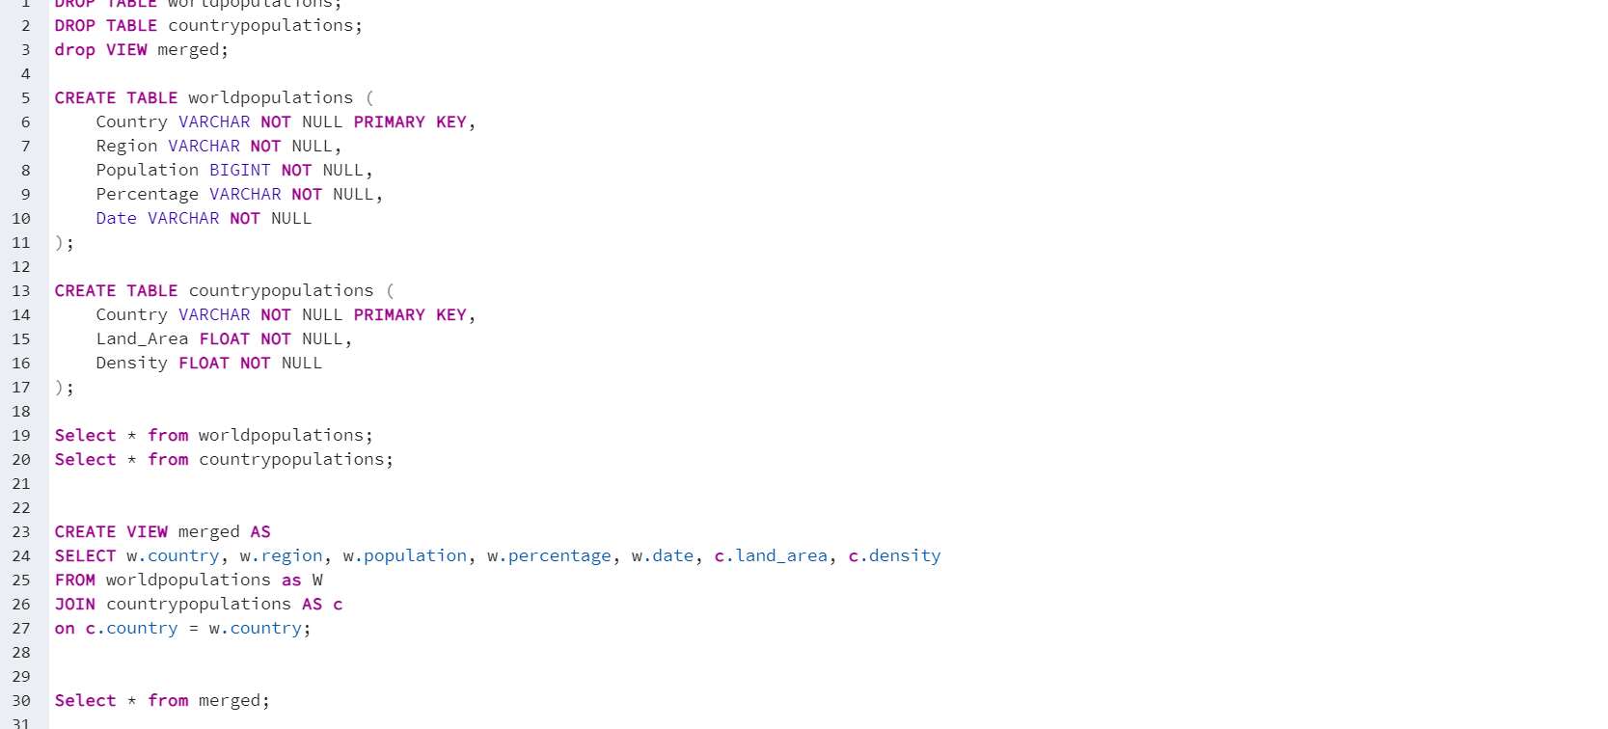
Postgre Database:

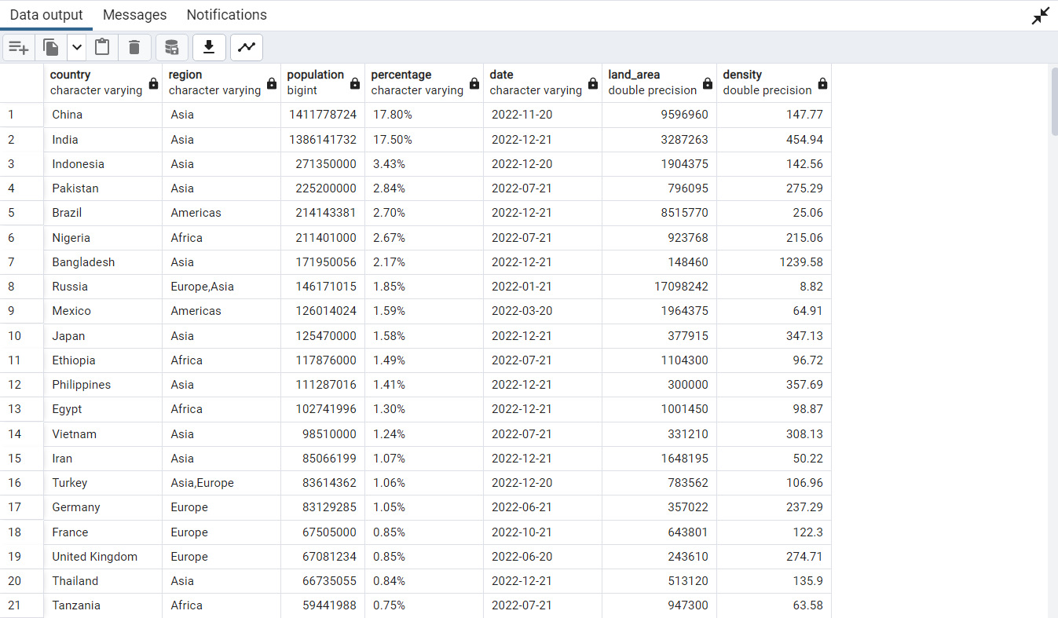
Loaded Table on SQL:

Loaded Table on Python:
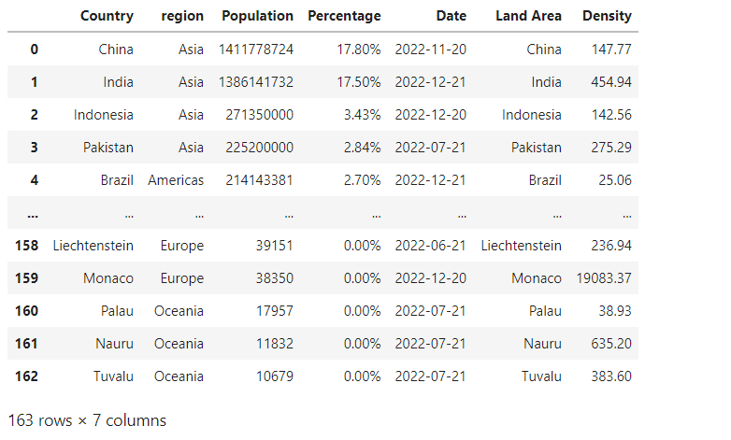

Questions & Analysis
With this database we aim to answer the following questions:
- What are the most densely populated nations?
- What are the least densely populated nations?
- What nations have the largest land areas?
- Is land area relational to population density?
Hypothesis
- The most densely populated nation will be India
- The least densely populated nation will be Greenland
- The largest land area belongs to Russia
- Land area will not be relational to population density
​Conclusion
The final database enables us to see the population, size and population density of 162 nations. The tables we created give us insights into important population statistics that, on a professional level could be utilised to better tackle issues such as overpopulation, make predictions on the growth (or decline) of nations, or enable a better understanding of the size of different markets across the globe.
Our Database does not support the hypothesis that India is the nation with the highest population density, with Monaco and Singapore, small but developed nations winning out:
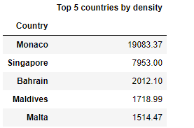

Greenland is the nation with the lowest population density, likely due to its largely volcanic and uninhabitable land area.
Russia also has the largest land area, supporting our hypothesis.
There is no clear correlation between population density and land area, which does support our hypothesis.
Overall, this database gives a good insight into significant population statistics on a global scale.

